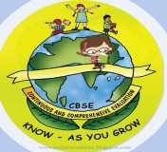
GREENWOOD PUBLIC SCHOOL, D.D. NAGAR
HOLIDAY HOMEWORK SESSION – 2020-21
CLASS – VIII

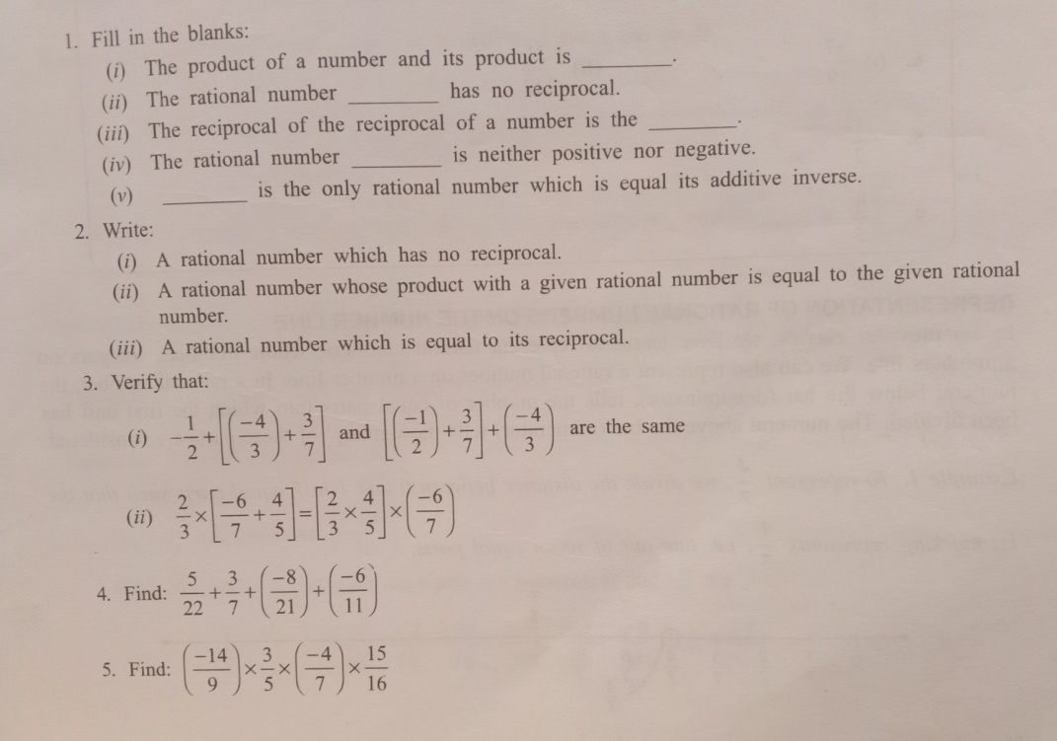
SUBJECT - MATHEMATICS

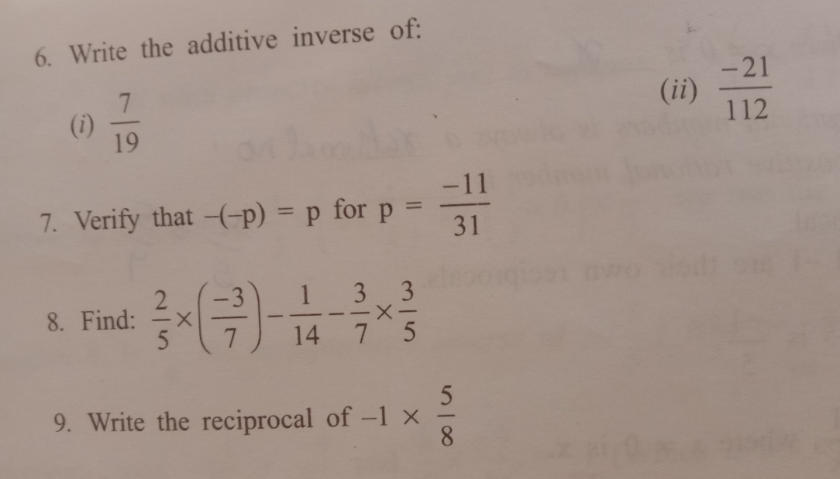

SUBJECT - COMPUTER
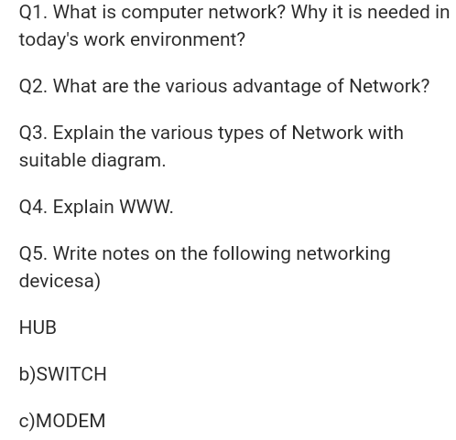

SUBJECT - ENGLISH
- Write a paragraph on the following:
[a] Covid- 19 [b] Women are the pride of our nation
- Write a letter to the Mayor of your city seeking a solution to the problem of waterlogging in your area. You are Rohit/Rohini of Patel Vihar, Gwalior.
- You are Riya Verma, a student of Ganga Public School, Jaipur. Write an application to your Principal requesting him to sanction you medical leave for 2 weeks. Give reasons, why you need the leave.
- Search two new words with their meaning daily.
Note: Complete Holiday Homework in A4 size papers.

SUBJECT – SCIENCE
- Follow all the steps of “Agriculture practices “in your home in pot or in small area of field and take the picture after performing every step and write some points about each step in file.
- Collect the 5-5 different Rabi and Karif Crop and paste on file and Write specific feature of each Crop.
- Make a chart showing classification of Micro-organisms by writing there characteristics and draw diagrams.
- Make Nitrogen Cycle and write explanation on chart paper.
- Solve the unit test paper-1 and assessment of chapter 1 and 2 .
- Learn notes of Chapter 1 and 2.

SUBJECT – S. St.
- Do exercise of chapter 1 & 2.
- Learn full Q/A of chapter 1 & 2.
- Write a debate on history is written for the rulers and by the rulers.
- Write some important sources of colonial history in chronological way.
- Find and mark any ten countries apart from India which have been victim of colonialism an outline map of India.
- Write a script base on the term of the east India company in India where detail of Nawab and life style of company official.
- Write the history of your family.
- If possible visit one historical place and write your experience in your word.
SUBJECT – SANSKRIT
- 'yksd ;kn djks vFkZ lfgrA
- esVªks ;ku dk fp= cukdj mlds fo"k; esa 5 okD; laLd`r esa fyf[k,A
- xhrk ds 'yksd fy[kdj mUgs daBLFk dhft,A
- N=ifr f'kokth jkts Hkksalys dk fp= lfgr muds thou dk ifjp; nhft,A
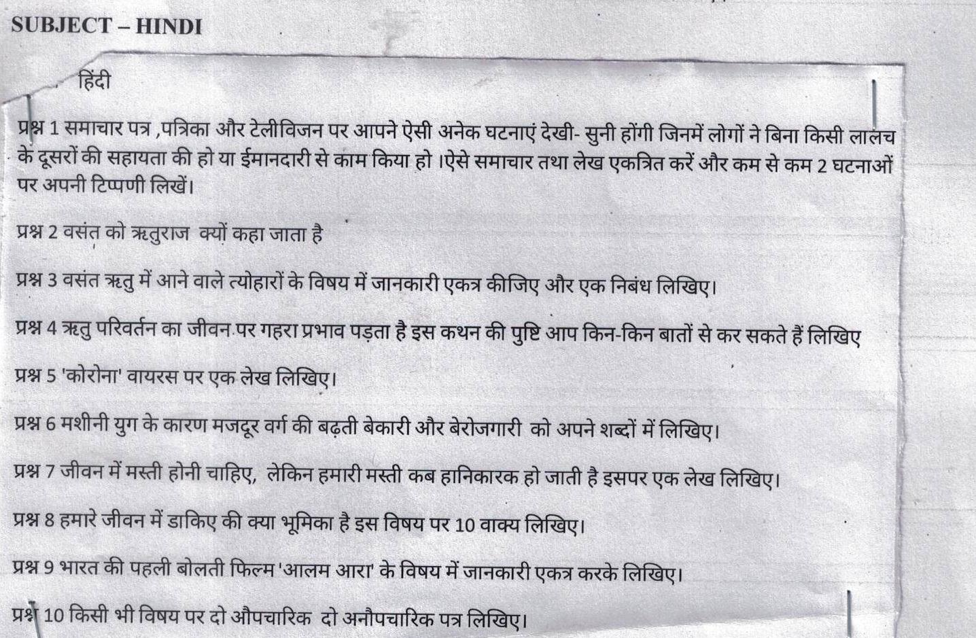
SUBJECT – HINDI

